**MZUMBE UNIVERSITY**



**FACULTY OF SCIENCE AND TECHNOLOGY**

**COMPUTING SCIENCE STUDIES DEPARTMENT**

**PRACTICAL TRAINING REPORT**

**NAME OF STUDENT**: MAKULU NILLAH MALIMI

**REGISTRATION NUMBER**: 14322033/T.20

**YEAR OF STUDY**: First Year

**PROGRAMME**: B.Sc. ITS

**COMPANY NAME**: MZUMBE UNIVERSITY

**COMPANY PHYSICAL ADDRESS**: Morogoro/Iringa Road, P.O BOX 1, Mvomero, Morogoro.

**INDUSTRIAL SUPERVISOR’S NAME**:

**MU SUPERVISOR**: DR. TUPOKIGWE

Contents

**ACKNOWLEDGEMENT** iii

**ABSTRACT** iii

**LIST OF FIGURES** v

**LIST OF TABLES** v

**ABBREVIATIONS AND ACRONYMS** vi

**CHAPTER ONE** 1

**1 INTRODUCTION** 1

**1.1** **Overview of the Company/Organization** 1

**1.2 Main functions of the organization** 3

**1.3 Organizational structure** 4

**1.4 Directorate of Information and Communication Technology (DICT)** 5

**1.5 Summary** 7

**CHAPTER TWO** 9

**2.0 Introduction** 9

**2.1 Task assignment** 9

**2.1.4 SOFTWARE INSTALLATION** 24

**2.2.1 APPROACHES TO SOLUTIONS** 27

**2.4 Summary** 29

**CHAPTER THREE** 30

**3** **INTERPRETATION AND ANALYSIS** 30

**3.1 Improvement of Existing Skills** 30

**3.2 New skills learnt** 31

**3.3** **Summary** 31

**CHAPTER FOUR** 32

**4 GAPS IN SKILLS AND TECHNOLOGIES** 32

**4.0 Introduction** 32

**4.1 Gap in Skills** 32

**4.2 Summary** 33

**CHAPTER FIVE** 34

**5.1 CONCLUSION:** 34

**5.2.1 Recommendation to the host 0rganization** 35

# **ACKNOWLEDGEMENT**

I’m extremely thankful and indebted to numerous people who provided some information, advice, guidance and other valuable contributions. It is because of their valuable support that made this field report possible. To mention few, I would like to acknowledge the following;

I wish to express my sincere gratitude to GOD for providing me guidance, health and opportunity to do my field project work in MZUMBE UNIVERSITY. It is only because of him all things were possible.

I sincere thank my local field supervisors Mr. KAIJAGE and their assistants for the training, encouragement, challenges and academic support from them. The field training was amazing because of their amazing supervision.

I would also like to thank Dr TUPOKIGWE who is my MU supervisor and all Mzumbe university staff members

Last but not least, I would like to thank my parents and all my fellow trainees who have been a constant encouragement and inspiration during my studies and have always provided me support in every walk of life.

# **ABSTRACT**

This field report is divided into five main chapters which are; introduction, task performed and lessons learnt, interpretation and analysis, gaps in skills and technologies, conclusion and recommendations. The following is a brief summary of each chapter:

**Chapter one:**

This chapter explains the organization in general including the name, physical location, historical background, vision, mission and the main functions of the organization. It also provides an overall picture of all the activities performed by the IT department towards accomplishment of the core functions of the organization.

**Chapter two:**

This chapter explains the tasks that I was assigned by a supervisor during the field practical training and the problems from which every particular task arose. It will also provide a clear description of proposed solutions on solving the problem, technical and non-technical approaches used to implement proposed solution and the results after implementation of the proposed solution.

**Chapter three:**

This chapter explains the improved skills and new skills that I and my colleagues learnt during my field practical training at Mzumbe University.In this chapter there is some description about new skills and improved skills which were provided during my field practical training at Mzumbe University.

**Chapter four:**

In this chapter there is explanation on skills are lacking and need to be improved and Gap in Technologies about what technology is lacking and need to be incorporated.

**Chapter five:**

This chapter conclude about my field practice which were performed during my field studies and it summarizes about all happened when I was in my field practice at Mzumbe University. Also provide some recommendation about what should be improved in Computing Science training programmes and what feedback may help Mzumbe University to improve further.

# **LIST OF FIGURES**

Figure 1: Organizational structure of Mzumbe University

Figure 2: Shielded twisted pair (STP)

Figure 3: Unshielded twisted pair (UTP)

Figure 4: Registered Jack – 45

Figure 5: Straight-through cable colors

Figure 6: Cross-over cable

Figure 7: Difference between straight through and cross over cabling

Figure 8: UTP cable’s outer covering being cut 1 inch.

Figure 9: Cross over standard arrangement of a cable

Figure 10: Straight through standard arrangement of a cable

Figure 11: Straightened pinch of the wires between fingers

Figure 12: Pushing of the 8 wires to the connector

Figure 13: Top view, the position of plastic shield and the wire ends at the connector

Figure 14: Ethernet Crimper and cinch down on the handles tightly

Figure 15: Ubuntu terminal Ping command results

Figure 16: Ping commands results

Figure 17: Computer maintenance at MU Library

Figure 18: Computer maintenance at MU Library

# **LIST OF TABLES**

Table 1: unshielded twisted pair categories

Table 2: Some of the network devices

Table 3: Standard arrangement of wire colors of the cable

# **ABBREVIATIONS AND ACRONYMS**

DICT – Directorate of information and communication Technology

MU – Mzumbe University

IDM – Institute of Development and Management

ICT – Information and Communication Technology

LAN – Local Area Network

FOL – Faculty of Law

UTP - Unshielded twisted pair

STP - Shielded twisted pair

RJ – Registered jack

DSL – Digital subscriber

IT – Information technology

PC – Personal Computer

MAC – Media Access Control

OSI – Open systems interconnection

IP – Internet protocol

URL – Uniform resource identifier

OS – Operating system

DVD – Digital versatile disc

CD – Compact disc

ROM – Read only memory

RAM –Random access memory

WAN – Wide area network

BIOS – Basic input/output system

# **CHAPTER ONE**

# **1 INTRODUCTION**

This chapter explains the organization in general including the name, physical location, historical background, vision, mission and the main functions of the organization.

## **Overview of the Company/Organization**

* 1. Organization profile

Mzumbe university is located 222 kilometers from Dar es Salaam and 25kilometers south west of Morogoro Municipality and about 3.5 kilometers off the Dar es Salaam – Zambia Highway.

**1.1.1 Historical Background**

Mzumbe University origin can be traced back to 1953 when the British Colonial Administration established a Local Government School in the country. The school was aimed at training local Chiefs, Native Authority Staff and Councilors. The level of training was elevated after Tanzania (Tanganyika) independence to include training of Central Government Officials, Rural Development Officers and local Court Magistrates. In 1972, the then Local Government School was merged with the Institute of Public Administration of the University of Dar es Salaam to form the Institute of Development Management (IDM-Mzumbe). IDM was a higher learning institution for training professional managers in the public and private sectors.

Given the natural growth of the Institute over the years of successful operation and the changing national and international human resource needs, the Government transformed it into fully fledge public University. This was made under the Act of Parliament No.21 of 2001. In December, 2006 the Mzumbe University Act No 21 of 2001 was repealed by the Universities Act of Tanzania No. 7 of 2005 and replaced by the Mzumbe University charter, 2007 which now guide the operations and management of the University. The mandate of the University as stipulated in the Mzumbe University Charter, 2007 focuses on training, research, publications and public service cum consultancy.

**1.1.2 Vision**

* Mzumbe University is recognized as a leading institution in Africa for demand driven knowledge generation, application, preservation and dissemination for socio-economic development by 2025.

**1.1.3 Mission**

* The Mission of the University is to provide opportunities for acquisition, development, preservation and dissemination of knowledge and skills through training, research, technical and/or professional services.

**1.1.4 Core values**

The following are the core values which guides Mzumbe University’s organizational culture.

* ***Transparency****:* Being transparent in all our work and dealings and stands ready for public scrutiny.
* ***Accountability****:* Being accountable to our stakeholders and to the community for the mandate and responsibilities bestowed upon us.
* ***Creativity and Innovativeness***: Always curious and striving to reach out and embrace new technologies and innovative methods of doing our work and contributing to socio-economic development.
* ***Integrity****:* Being exemplary in our behavior and acting with honesty and impartiality in all our transactions.
* ***Team work****:* Working at all times as a team.
* ***Diligence****:* Being meticulous and through in whatever we do.
* ***Respect for others****:* We always respect personal opinion academic freedom.
* ***Responsive to society needs****:* We strive to continuously respond to current and future needs of the society.

## **1.2 Main functions of the organization**

* To encourage academic staff and students to learn and seek knowledge and truth;
* To produce highly educated and adequately trained experts well prepared and equipped with requisite skills for self-employment and manning of key positions in both public and private sectors;
* To promote, facilitate and sponsor research into technological, social, economic, political and cultural spheres for the welfare and development of mankind within and outside the United Republic of Tanzania;
* To seek or institute and award fellowship, scholarships, bursaries, medals, prizes and other forms of awards, assistance or sponsorship for the advancement and dissemination of knowledge and pursuit of truth;
* To arrange for the publication and dissemination of material produced in connection with the work and activities of the University;
* To conduct and administer examination and confer degrees, diplomas, certificates, and other awards of the University;
* To develop, promote and undertake the provision of adult, continuing and distance education for the enhancement of good governance and efficacious solution to socio-economic and political problems;
* To develop and maintain a reference library and provide library services in the fields of study undertaken by the University;
* To cooperate with the government of the United Republic of Tanzania in the planned and orderly development of quality education, science and technology in the United Republic of Tanzania;
* To establish links and to cooperate with other national and international institutions in the initiation and conduct of cooperative research, publication and training programmes for the mutual benefit of the cooperating institutions and the United Republic of Tanzania and generally for the pursuit of the mission of the University;
* To do any other thing in accordance with the provisions of the Mzumbe University Charter or any other written law in force in the United Republic of Tanzania in pursuance of the mission of the University.

## **1.3 Organizational structure**

The University consists of two campus colleges, two schools, three faculties, one institute, four academic directorates and other organs that performs various activities in order to accomplish the core functions of the organization. Below is the structure of Mzumbe University;

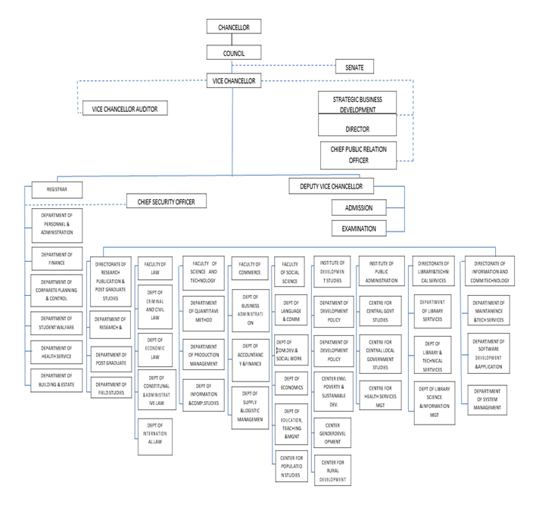

Fig 1: Organizational structure of Mzumbe University

## **1.4 Directorate of Information and Communication Technology (DICT)**

The DICT handles all matters related to information and communication technology activities at the University. Its major objective is to ensure that the University has the right technology at the appropriate time and with a right quantity and quality. It also ensures that the ICT services are readily available to users in the University and downtime is minimal.

1.4.1Mission of the Directorate

* The mission of DICT is to provide technical support related to ICT services to all stakeholders of Mzumbe University and its partners.

1.4.2 Vision of the Directorate

* The vision of the Directorate is to facilitate the University with wide access to and utilization of Information and Communication Technology and to enhance the position of Mzumbe University as centers of academic excellence, and its contribution to the sustainable development of the society by using ICTs.

1.4.3 Responsibilities done by DICT on Mzumbe University are as follows

* To advise the management on the appropriate ICTs to acquire.
* To advise the management on the acquisition of both hardware and software.
* To advise the management on the segmentation of the LAN to logical division.
* To advise the management on the development and maintenance of corporate and other databases.
* To advise the management on how to share resources in the LAN.
* To service and repair computer systems and their peripherals.
* To supervise and monitor the usage of computer equipment in staff offices and students’ laboratories.
* To organize and supervise major repair on ICTs in case MU technicians fail to solve the problem.
* To develop and customize computer software.
* To set ICT utilization policy and user guidelines and oversee its implementation.
* To ensure that the MU Local Area Network (LAN) works properly all the time.
* To develop and maintain MU website.
* To design and facilitate specialized computer applications courses; and Any other function as may be directed by the University Management through the Deputy Vice Chancellor.

## **1.5 Summary**

Mzumbe University is a Governmental institution which issues excellence educational achievements for undergraduate and postgraduate students in Tanzania. It was established in 1972 as the Institute of Development and Management(IDM) before transformed into fully public university in 2001.

The University consists of different organs that performs various activities in order to accomplish the core functions of the organization.

The Mission of the University is to provide opportunities for acquisition, development, preservation and dissemination of knowledge and skills through training, research, technical and/or professional services.

Mzumbe University is recognized as a leading institution in Africa for demand driven knowledge generation, application, preservation and dissemination for socio-economic development by 2025.

The DICT handles all matters related to information and communication technology activities at the University. Its major objective is to ensure that the University has the right technology at the appropriate time and with a right quantity and quality. It also ensures that the ICT services are readily available to users in the University and downtime is insignificant.

# **CHAPTER TWO**

**TASK PERFORMED AND LESSONS LEARNT**

## **2.0 Introduction**

This chapter explains the tasks that I was assigned by a supervisor during the field practical training and the problems from which every particular task arose.

It will also provide a clear description of proposed solutions on solving the problem, technical and non-technical approaches used to implement proposed solution and the results after implementation of the proposed solution.

## **2.1 Task assignment**

During my field practical training at Mzumbe university different tasks were assigned but the main task was Network installation and maintenance. Other minor tasks were as follows; maintenance and repair, installation of windows and other application program, network troubleshooting, driver installation

2.1.1 NETWORKING

Mzumbe university have got a lot of technique like network in both aspect in cabling and installation. The networking system used at Mzumbe University is local area network (LAN) and the major uses of the network is for sharing different resources such as hardware, software, data and different information from each office which have a computer system.

What was supposed to be done here is to install the local area network within different buildings like staff offices, and laboratory (geneva laboratory,JICA), Faculty of law building as well as Library of Mzumbe University.

2.1.1.0 NETWORK CABLES

Cable is the medium through which information usually moves from one network device to another. There are several types of cable which are commonly used in LAN’s installation. In some circumstances, a network will employ only one type of network cable, other networks will use a diversity types of cable. The type of cable chosen for a network is related to the network's topology, protocol and size.

Understanding the characteristics of different types of cable and how they relate to other aspects of a network is necessary for the development of a successful network.

Here under are the different types of cables used in computer networking

* Unshielded twisted pair (UTP) cable
* Shielded twisted pair (STP) cable
* Coaxial cable
* Fiber optic cable

Twisted pair cabling comes in two varieties i.e. shielded and unshielded twisted pairs. Unshielded twisted pair (UTP) is the most popular and is generally the best option for school networks.

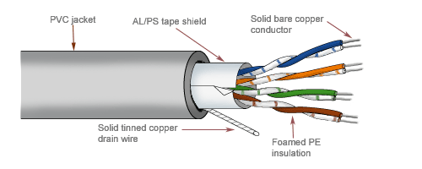

Figure 2: Shielded twisted pair (STP)

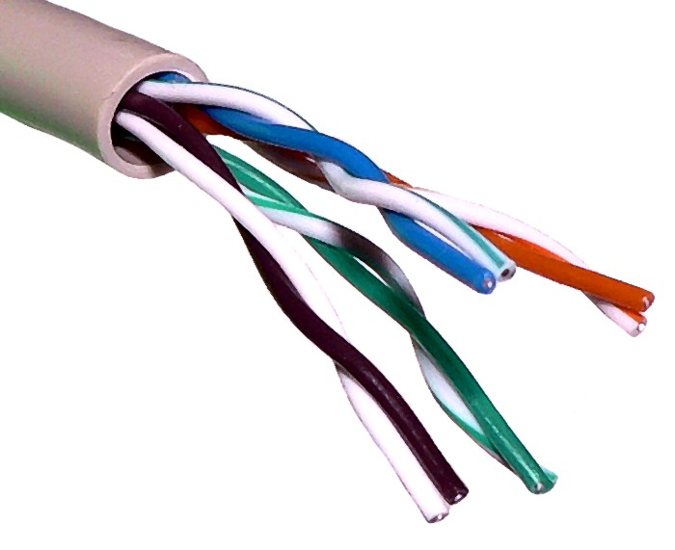

Figure 3: Unshielded twisted pair (UTP)

Unshielded twisted pair are categorized consequently from speed and as well as its uses, see the table below:

|  |  |  |
| --- | --- | --- |
| **Category** | **Speed** | **Uses** |
| 1 | 1 Mbps | Voice Only (telephone wire) |
| 2 | 4 Mbps | Local Talk |
| 3 | 16 Mbps | 10 BaseT Ethernet |
| 4 | 20 Mbps | Token ring (rarely used) |
|  | 100 Mbps (2 pair) | 100 BaseT Ethernet |
| 5 | 1,000 Mbps (4 pair) | Gigabit Ethernet |
| 5e | 1,000 Mbps | Gigabit Ethernet |
| 6 | 10,000 Mbps | Gigabit Ethernet |

Table 2: unshielded twisted pair categories

2.1.1.1 REGISTERED JACK – 45 (UTP CONNECTOR)

The standard connector for unshielded twisted pair cabling is an RJ-45 connector. It is a plastic connector that looks like a large telephone-style connector (See fig. 2). A slot allows the RJ-45 to be inserted only one way. RJ stands for Registered Jack, implying that the connector follows a standard borrowed from the telephone industry. This standard designates which wire goes with each pin inside the connector.

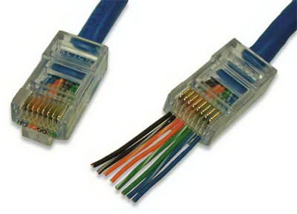

Figure 4: Registered Jack – 45

2.1.1.2 STRAIGHT THROUGH AND CROSSOVER CABLES

Wiring in twisted pair cable is configured in two ways which are as Straight through and Cross over.

Straight through cable is a type of twisted pair cable used to connect different devices such as computer to router, computer to hub on a local area network, computer to a cable/DSL modem's LAN port, router's WAN port to a cable/DSL modem's LAN Local Area Network port and it also connects two switches/hubs with one of the switch/hub using an up-link port and the other one using normal port.

This type of cable is also sometimes called a patch cable and is an alternative to wireless connections where one or more computers access a router through a wireless signal.

The figure and the table below describe how does straight-through cable looks like and the arrangement of wires of the same color on both sides (side A and side B) of the cable.

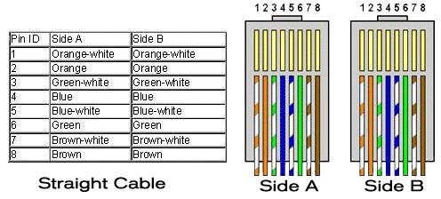

Figure 5: Straight-through cable colors

While a cross over cable is the type of twisted pair cable used to connect same devices such as computer to computer, router to router and hub to hub on a local area network.

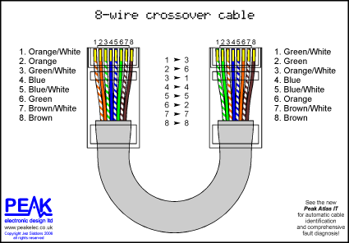

Figure 6: Cross-over cable

The figure below at least shows the differences between the two terms straight through and cross over wiring:

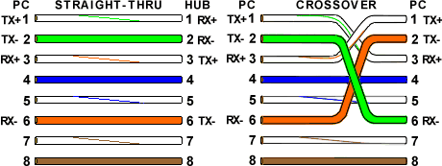

Figure 7: Difference between straight through and cross over cabling

Below are some devices used to make a straight through or crossover cable and their respective uses;

|  |  |  |
| --- | --- | --- |
| **Device picture** | **Device name** | **Uses of device** |
| **http://www.groundcontrol.com/galileo/images/bulk_cable.jpg** | Bulk Ethernet Cable - Category 5 or CAT5 | -Use to make short pieces of wire in order to make straight through or crossover cable |
| **C:\Users\HAMIAR\Desktop\images.jpg** | RJ 45 Connectors | -Use to put at both ends of pieces of wire after it has been unwind during making of straight through or cross over cable |
|  | RJ-45 Crimping tool | -Use to pinch the connector after the ends of wire it has been cut straight and placed inside the connector so as to be well fixed. |
| **C:\Users\HAMIAR\Desktop\images.CABLEjpg.jpg** | RJ 45 Cable Tester | -Use to test if the ends of wire are well fixed and the colors are properly arranged at the ends of the connector. |

Table 2: Some of the network devices

2.1.1.3 STEPS TO MAKE STRAIGHT THROUGH OR CROSS OVER CABLE

Step 1

Use the crimping tool’s razor blade to cut the outer covering plastic sheath 1 inch from the end of the cable by placing it in the stripping hole in crimp tool, squeeze the handles slightly then pull the crimp tool away from you to remove the outer covering from the inner strands of cable as shown below;



Figure 8: UTP cable’s outer covering being cut 1 inch.

Step 2

Unwind and arrange the colored strands according to standards (T568 B and T568 A).To create the straight through cable you will have to use either T568 A or T568 B on both ends of the cable,while creating the cross over cable you will have to use T568A on one end and T568B on the other end.

Here under is a that table shows the arrangement of colored strands according to standard

|  |  |  |
| --- | --- | --- |
| **Pin number** | **T568B standard** | **T568A standard** |
| **1** | White Orange | White Green |
| **2** | Orange | Green |
| **3** | White Green | White Orange |
| **4** | Blue | Blue |
| **5** | White Blue | White Blue |
| **6** | Green | Orange |
| **7** | White Brown | White Brown |
| **8** | Brown | Brown |

Table 3: Standard arrangement of wire colors of the cable

Make sure that after the arrangement the wires looks like the one shown below according to standards either a straight through or a cross over cable

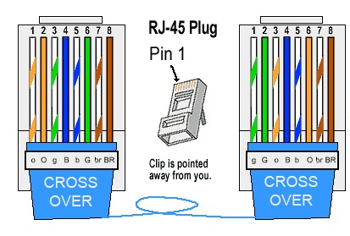

Figure 9: Cross over standard arrangement of a cable

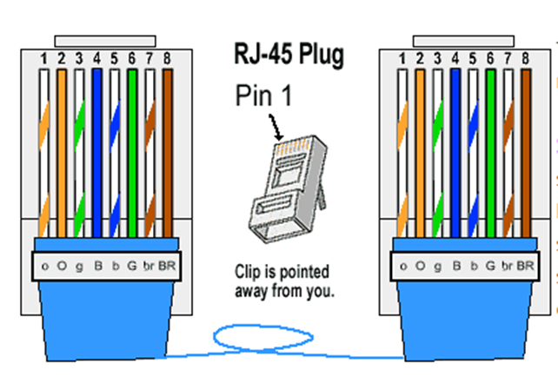

Figure 10: Straight through standard arrangement of a cable

Step 3

Pinch the wires between your fingers and straighten them by cutting at the ends using a clipping tool as shown.

The color order is important to be correct

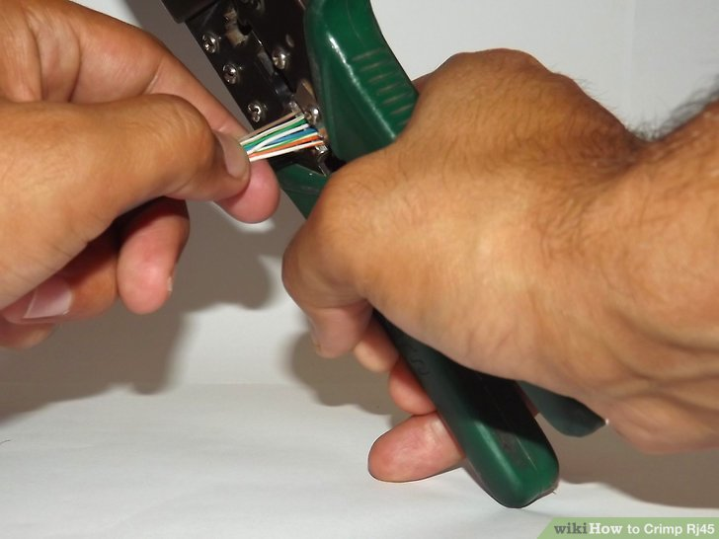

Figure 11: Straightened pinch of the wires between fingers

Step 4

Carefully push all 8 colored wires into the connector and note the position of the blue plastic shielding at the ends of the connector also note how the wires go all the way to the end as shown below

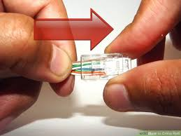

Figure 12: Pushing of the 8 wires to the connector

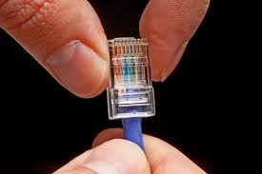

Figure 13: Top view, the position of plastic shield and the wire ends at the connector

Step 5

Carefully place the connector into the Ethernet Crimper and cinch down on the handles tightly as shown.

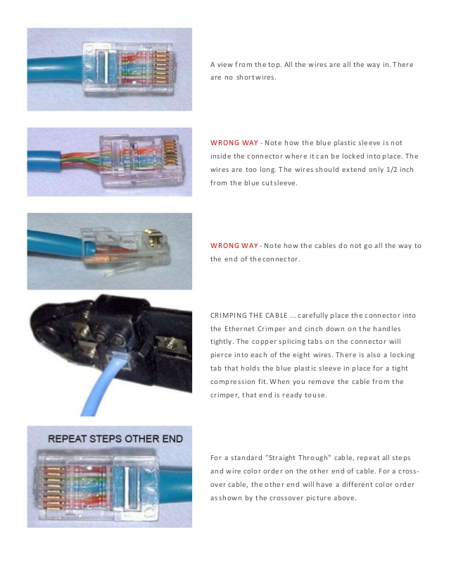

Figure 14: Ethernet Crimper and cinch down on the handles tightly

The copper splicing tabs on the connector will pierce into each of the eight wires. There is also a locking tab that holds the blue plastic sleeve in place for a tight compression fit. When you remove the cable from the crimper, the cable is ready to use.

Make sure you test the cables by using RJ 45 testing device before you install them.

2.1.2 SWITCH CONFIGURATION

A switch in network concern (also called switching hub, bridging hub, officially MAC Bridge) is the one of computer devices that connects devices like computers together on a computer network, by using packet switching to receive, process and forward data to the destination device. Unlike less advanced network hubs, a network switch forwards data only to one or multiple devices that need to receive it, rather than broadcasting the same data out of each of its ports.

A network switch is also a multiport network bridge that uses hardware addresses to process and forward data at the data link layer (layer 2) of the OSI model.

**Processes to consider during configuration:**

First of all you have to login into the switch by using an external emulator like **Telnet** or **PuTTY.** During the configuration of the switch ports, each port was configured individually. This was done using the PUTTY Terminal with network commands specifically for delivering the configuration of ports.

After the configuration process then each port was tested to see if there is incoming network or there is flow of data through the communication network devices. There after we finalize the installation of network after seeing that all the ports within the switches are working fine.

2.1.3 NETWORK TROUBLESHOOTING

In networking, data transfer from source to destination is accomplished if data pass through the 7 OSI layers which are Application Layer, Presentation Layer, Session Layer, Transportation Layer, Network Layer, Data Link layer and Physical Layer.

Sometimes data may fail to reach to the destination due to network problems that may occur in any of the OSI layers.

To solve the problems, we need to identify them by passing at different layers, some of the problem can be identify using Cisco Commands such as “TRACEROUT and “PING” commands this is mainly used on the network layer.

Ping command used to check if there is a connection between the Sender and the Receiver while trace route command is used to trace the path between the sender and the receiver.

**Network troubleshooting by PING commands**

On a computer network, a ping tool is built into most operating systems like all windows(10,8,XP,7) and Linux distributions(Ubuntu,Debian,red hat Kali Linux), that works in much the same way. You issue the ping command along with a specific URL or IP address. Your computer sends several packets of information out to that device, and then waits for a response. When it gets the response, the ping tool shows you how long each packet took to make the round trip—or tells you there was no reply.

Step 1

Open the terminal found on your Computer by typing CTRL+ALT+T, bellow is the screenshot of the terminal found on my Ubuntu operating system.

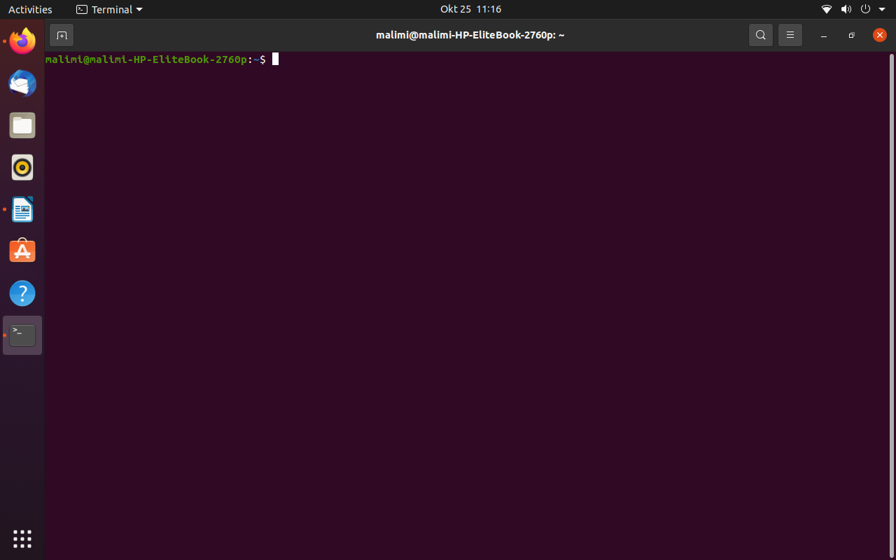

Figure 15: Ubuntu terminal

Step 2

Type the following command, PING [IP Address of the destination host] then heat Enter button,

Examples: - PING 127.0.0.1 loopback address

After you heat Enter button, the following output will display on the command prompt as shown on the following screen shot, but this output will display if the destination is reachable.

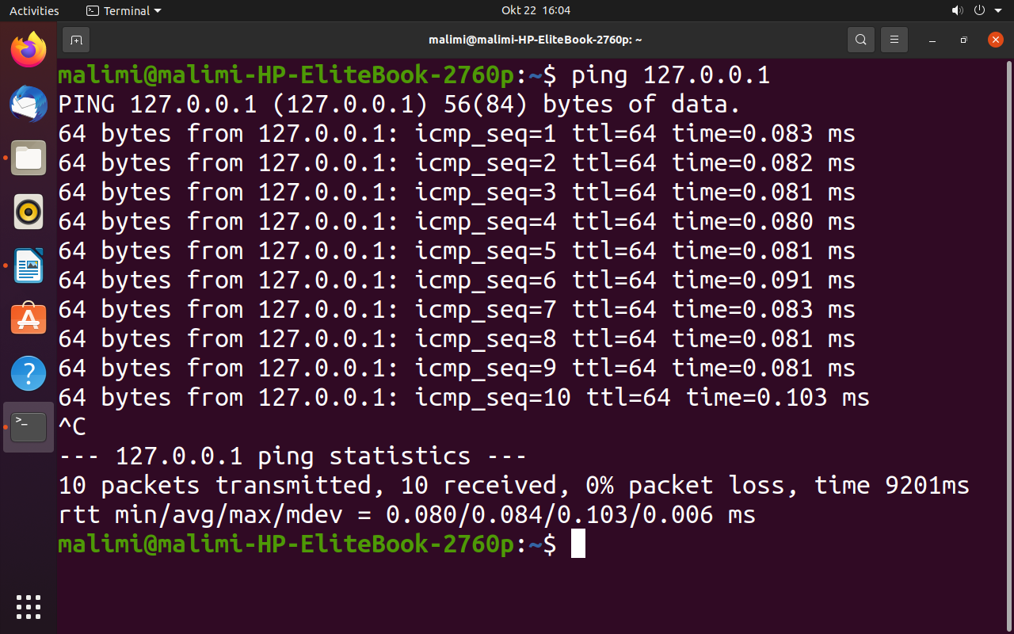

Figure 15: Ubuntu terminal Ping command results.

**How to troubleshooting using traceroute command**

Note:If you use the Ubuntu operating system you should to install it by using command

“sudo apt-get install traceroute”**.**

*TRACEROUTE:* Is a tool or command used to determine the path between two connections,it can show you the path a packet taken from your computer to one you specify.

* Return the names or IP addresses of all the routers between two devices
* It will list all the routers it passes through until it reaches its destination, or fails to and is discarded.

In addition to this, When you execute the traceroute command ICMP (Internet Control Message Protocol) is used to transmit packets to the destination with a Time to Live (TTL) value of 1, and this increases for each hop. When everything goes smoothly, each hop has to reduce the TTL by one, and when it becomes zero, the packet is dropped, and a message is sent to the receiver. The problem that often arises is that ICMP is often partially or completely filtered out by intervening routers or firewalls.

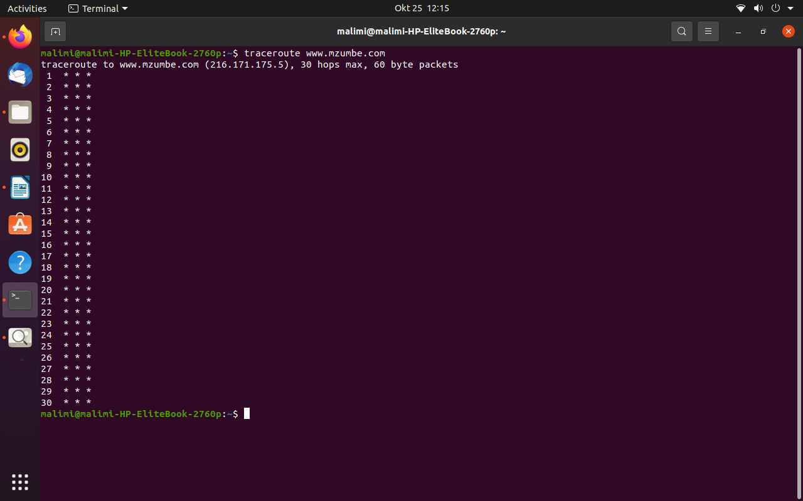

Figure 16: Ubuntu terminal Traceroute command results.

In Windows, select *Start > Programs > Accessories > Command Prompt*.

Enter the word *tracert*, followed by a space, then the domain name.

Example

Type the following command on command prompt on windows, tracert www.mzumbe.ac.tz**.** After clicking the enter button the same result as using Ubuntu terminal .

### **2.1.4 SOFTWARE INSTALLATION**

Installation of different operating systems like windows of difference version and Linux distributions is another important part I practice more and more during on my field practical training at Mzumbe

university and other application programs such as Microsoft office, adobe reader, vlc media player, antivirus.

2.1.4.1 WINDOW INSTALLATION

An **operating system** (**OS**) is system software that manages computer hardware and software resources and provides common services for computer programs. The operating system is a component of the system software in a computer system. Application programs usually require an operating system to function.

In Mzumbe university Microsoft windows 10 is mostly used as an operating system since it is friendly used for both technical and non technical skills.

2.1.5 COMPUTER TROUBLESHOOTING AND MAINTENANCE

Another minor task that we did during my field practical training at Mzumbe university was computer troubleshooting and maintenance that we rarely attend to; we diagnosed computers generally so that we can be able to determine the existing problems.

Firstly, we started doing some troubleshooting on when pc is starting up, and see how long does it takes for it to be ready. Then we check the installed Operating system and lastly installed updates if there we no updates installed then we connect the PC to the internet and start to do windows update.

Then after we became aware on different hardware problems simply by observing attributes of computer performance as follow;

1. The problem with Ram seem to be a very complicated problem for us but only we did a trial and error method which simply like replacing RAM Random Accessing Memory with the other one.
2. The problem with the hard drives; we detected this problem simply because the system failed to boot and it gave out a certain beeping sound.
3. Printer troubleshooting; printer can fail to print due to this possible problem jamming paper in which we remove cartridge and removing the jammed paper, shortage of ink where we replace or refilling to the cartridge ink jet.

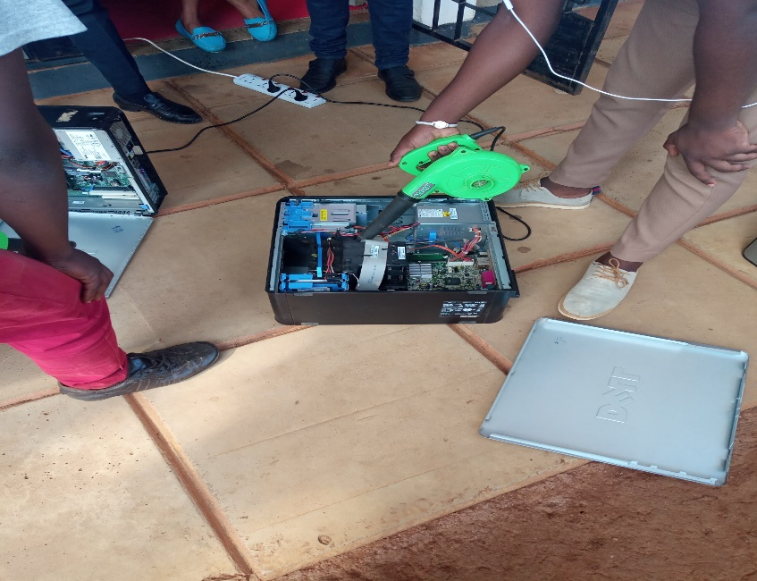

Figure 17: Computer maintenance at Bohari building

2.1.6 PROBLEMS ENCOUNTERED

During the field practical training, some assigned tasks were encountered some problems which made nothing to work effectively, the following were the problems arose when handling the tasks assigned:

* Failure to connect successfully the R-J 45 Connection with the UTP Unshielded Twisted Pair Cable, this led to the improper coming of network signals.
* Poor arranging of colors made nothing to work proper either since in each arrangement whether it is straight forward or cross over there is principles and rules which must be followed; like matching the colors respectively.
* Poor knowledge in coding commands for configuring switch ports using PUTTY terminal,as bellow Ubuntu terminal command.

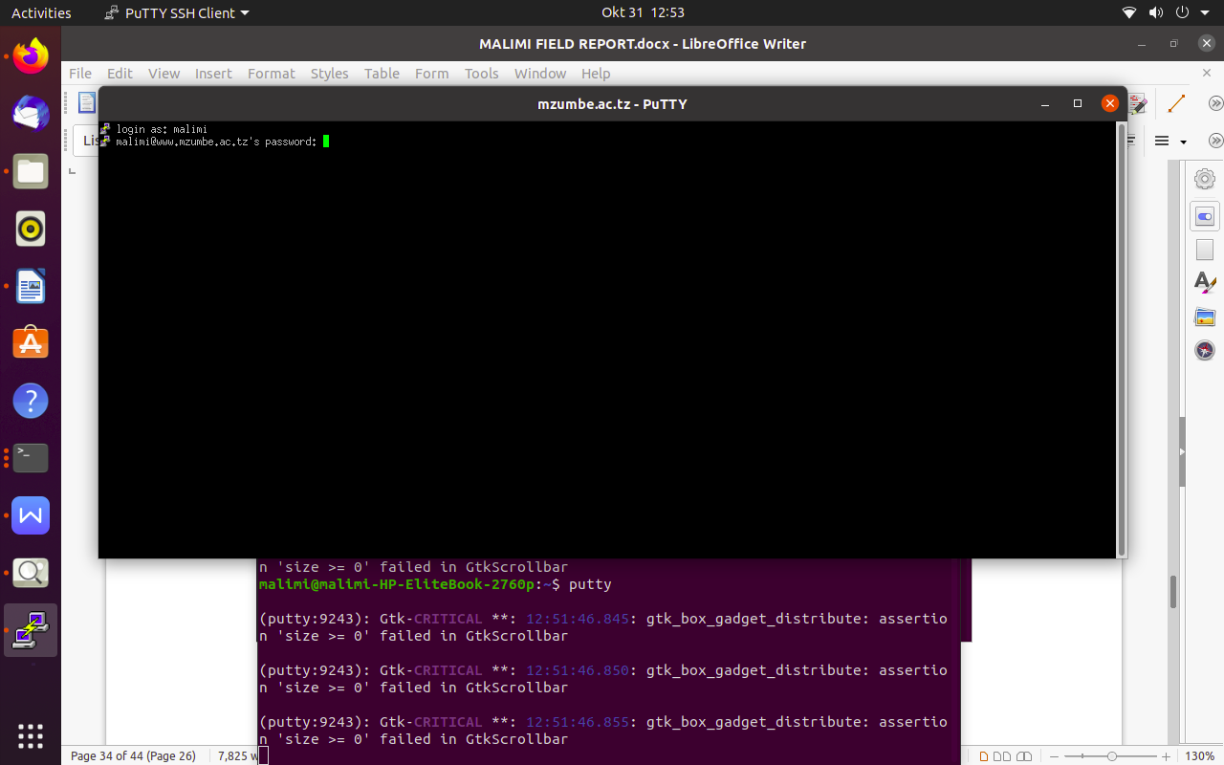

Error displaying after minutes due to the lack of knowledge of putty tool.

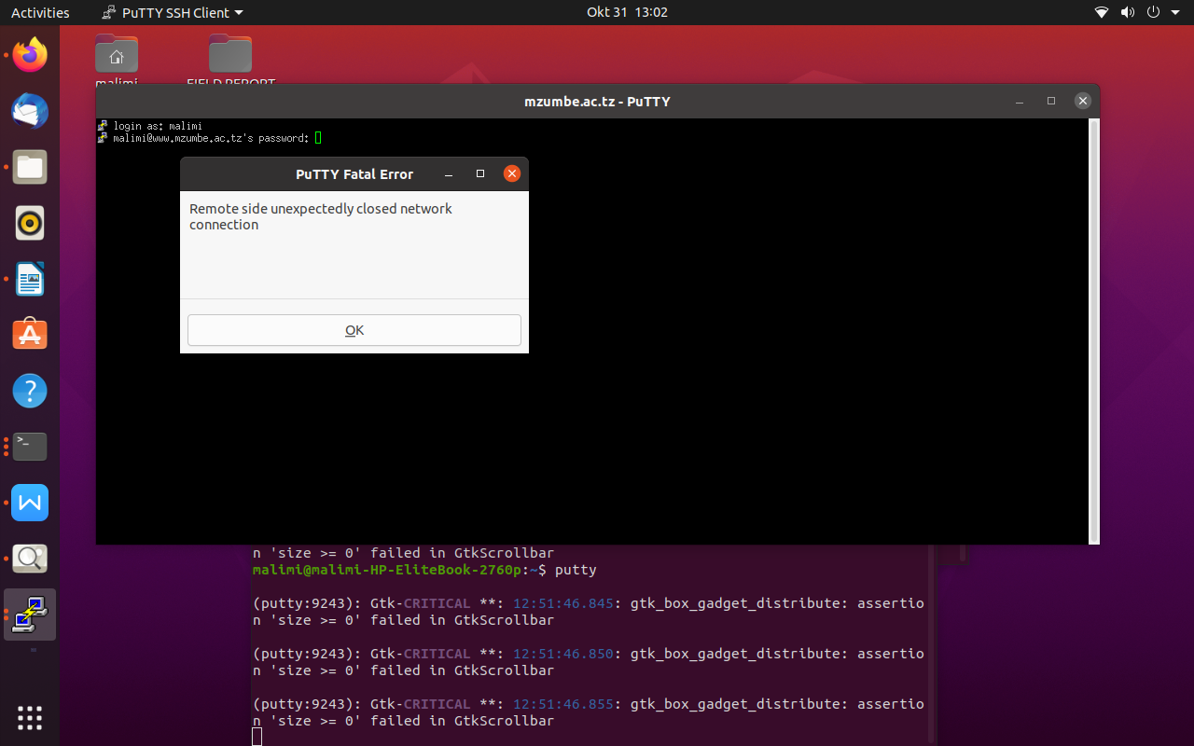

* Poor knowledge on how to troubleshoot a network by using PING or TRACEROUT commands.
* Poor knowledge on identifying hardware problems and to solve them as soon as possible.
* Poor co-operation among students on field practical training.

2.1.6.1 PROPOSED SOLUTIONS

The following are the proposed solutions so as to solve the problems encountered in performing the assigned tasks during my field practical training at Mzumbe University:

1. Understanding colors matching in wiring cables:

Here one should be able to understand the order and sequence of colors in different approach whether it is straight forward or it is cross over cabling, so as it won’t lead to confusion and hence there will be no incoming network to other communication devices.

1. Understanding Commands with PUTTY terminal:

Each and every one was supposed to be able to understand coding with PUTTY so as to able to configure ports successfully with no errors and hence to be able to determine which ports have conflicts. So, knowing the commands it will be very easy to troubleshoot what port has conflict.

1. Understanding PING and TRACEROUT commands

Since this was one of the challenges, we faced during our field practical training, it is supposed that we understood Ping and TRACEROUT commands so that we could be able to troubleshoot network problems by using PING and TRACEROUT commands.

1. Understanding the R-J 45 connection:

For a full and successful connection with no errors one should be able to understand clearly and practice how to connect UTP cable very well and in order such that he or she won’t mix colors in such a way that they won’t be in order that they are required to be.

1. Understanding computer architecture

In order to technically solve different hardware problems in computer maintenance and repair, each and every student should have adequate knowledge on the computer architecture.

## **2.2.1** **APPROACHES TO SOLUTIONS**

In approaching to solution there were Technical and other Non-Technical approaches to solutions:

**2.2.1.1 Technical approach:**

This was fully technical in such a way that for example one after troubleshooting a port and notice that the port has conflict and so causing for no incoming network connections, hence this was the technical approach to solution.

After the cable within the port was checked technically then seen for not matching colors with the cable on the wall hence the cable thrown out so as to be configured again.

Also when troubleshooting a PC when a particular hardware was not performing well, the technical approach was concerned by starting to firstly see if the drivers were well installed within a PC and when seem to be not installed hence one could start to do update on the drivers or re-installation, Not only that but also when one could use a technical approach on solving a problem that is facing a certain printer that a printer might be not working properly; so one may start checking if a cable is connected well between a printer and a PC after that then problem may be resolved by making a trial on different technical approach that might lead to a solution of a problem.

**2.2.1.2 Non-Technical approach:**

In accomplishing the assigned tasks, not everything required technical details to reach to the solutions. Things like working hard, cooperation, punctuality, etc. were very advisable for everyone so as to undertake all the assigned tasks within a significant time.

* 1. **RESULTS OF THE PROPOSED SOLUTION**

After the solutions been implemented well it was clearly obvious for everybody around to find how the solution came to solve the problems, like in Networking if the cables wiring was incorrect due to the mixing up of colors then the solution was to do rewiring of the cables so as to have the incoming connections.

2.3.1 User’s adaptations to solutions

During the field practical training, it is wealth when users or members of the organization find how problems have been solved. The members of organization seem came to want an idea how things get done, or how solutions work so fine.

All in all, the organization was satisfied accordingly, for example when we solve a particular problem in networking like restarting a not working server then there after leading to a network to work fine the organization came to be happy about it, simply they behave in a positive way.

2.3.2 Achievements from task assigned

I myself, I definitely benefit a lot from each and every aspect that we passed through about any task that I was assigned by my supervisor in such a way that I must tell how I benefit as follows:

**Network Cabling and Termination:**

This was quite interesting since that in class only we did was a theory concerned, but during my field practical training I actually learn a lot of staffs about networking practically which is good for a market outside; so, for now am very skillful in networking cabling and termination as well as installation

**Computer Troubleshooting and Maintenance:**

During my field practical training I enjoyed troubleshooting a PC as well doing some installation; like windows installation ,Linux installation and many other programs without forgetting installation of drivers using the driver pack solution it was quite interesting, I really benefit from that for sure.

**Web Base Application Designing.**

This is another skill a have got from Mzumbe University during Field Training ,in this case were are developing the system concern the field issues(Mzumbe Online Field Application Management System) by using the Python language with the Django framework as popular one on web base python project ,on which help the students from Mzumbe University and other institutes to apply online without manually to do it and get a report on whether selected or not at time.

## **2.4 Summary**

During my field practical training at Mzumbe University on the Directorate of Information and Communication Technology, it was a great opportunity to learn a lot of new staffs from the task which were assigned to me also from my colleagues. In my field practical training major tasks like Network cabling was really interesting to me, since during our classes we only did theories which was not enough to make us be experts in networking.

In networking cabling we did a lot of installation of networking to different buildings, under the guidance from our supervisor Mr. Kaijage we made it through, sometimes there were some problems appearing after making some errors during doing a task, hence proposed solutions may be given out and it can be by technical approach or Non-Technical approach then providing solution to a problem.

Not only that network cabling but also they're minor task like computer troubleshooting as well as other peripheral devices like printers, Mouse, and keyboard. This also was quite interesting since that it was easy to troubleshoot them cause many times the issue was about drivers were not installed require for installation or update in order for a particular hardware like printer to function properly.

During attending to tasks which were assigned sometimes problems appears which require solutions at a time, so it was our duty to diagnosis what is the problem and what is the solution; proposed solutions were considered and in turn lead to problem solved which in turn make the organization behave positive accordingly to the suggested solutions which tend to bring about solution concern the particular problem.

Last but not least, during the task assignment we really benefit for sure since that we learned a lot of new staffs that we never learnt in class, as well as the organization simply enjoyed our company and support to accomplish tasks like installation of network in different buildings.

# **CHAPTER THREE**

## **3.** **INTERPRETATION AND ANALYSIS**

**3.1 Improvement of Existing Skills**

During my field practical training at Mzumbe University, I and my colleagues we learned many things which contributes on increasing many skills which I was lacking before, since in Mzumbe University the teaching methodology which is employed is theory based so those studied computer issues are not well understood until they are performed practically.

Therefore, the period of my field study I practiced many things that I learned theoretically when I was studying in the class but in field, I practiced a lot as the result of improving my skills. The followings are the skills that I gained during my field practical based on task given

**3.1.1 Computer networks skills**

During my field all the computer networks-oriented activities as explained in the previous chapter which were assigned to me contributed a lot on improving my skills on issues which are computer network-based activities, such activities include construction of ethernet cables, construction of computer networks in different computer laboratory. This is because in class sessions I learned theoretically but during field I get many experiences compared to those I got in the class. So those tasks which was given to me contributed a lot on transforming my theoretical understanding on computer networks into practical understanding.

**3.1.2 Preventive maintenance skills**

This skills is the one of the basic 3 skills operated under Directorate of Information and Communication Technology (DICT) In Mzumbe University which are

* system analysis and design
* web designing and
* preventive maintenance.

Its major objective is to ensure that the University has the right technology at the appropriate time and with a right quantity and quality. In DICT there are three issues which are performed, which are system analysis and design, web designing and preventive maintenance.

Preventive computer maintenance includes all measured which are taken on computers found in the organization in such a way that if there is any issue which occur on the computer which need the help of assistant which is computer expert, then DICT is involved directly. For example, during my field all such problems were directed to us who were performing field in Mzumbe University on the Directorate of Information and Communication Technology as the result of improving our skills on preventing any computer problems. And such problems occurred and were troubleshooted includes installation of software’s (operating systems, vlc, Microsoft offices, ant virus installation), connecting computer systems (keyboard, UPS) which in turn contributed on improving my skills.

## **3.2 New skills learnt**

The skills that I have got from field practical in Mzumbe University that conducted under the Directorate of Information and Communication Technology are

Web based program designing**,** configuration of network devices like router and switch,Linux server using Ubuntu distribution for more speed and security operating system.

**3.2.1 Web base designing**

This knowledge was given to those students who was performing field practical training at Mzumbe University on the Directorate of Information and Communication Technology. So, such issue was new to me and to some my colleagues and become my new skill I learnt during my field practical.

**3.2.2 Network devices Configuration**

Establishment of different network access device like router and switch configuration in mzumbe university that offered by Directorate of Information and Communication Technology (DICT) such activities lead on new experience on case of practical become my new learned skill.

## **Summary**

During my field practical training at Mzumbe University on the Directorate of Information and Communication Technology, it was a great opportunity to learn a lot of new staffs from the task which were assigned to me also from my colleagues. In my field practical training major tasks like Network cabling was really interesting to me, since during our classes we only did theories which was not enough to make us be experts in networking.

My field study in Mzumbe University on the Directorate of Information and Communication Technology (DICT) become more important to me because I learned many things which transformed my theoretical understanding into practical understanding. This Is due to the fact that in my learning activity many things I learn theoretically so my field practical has contributed much on increasing my skills and giving some new skills which, I was not knowing about them before field.

# **CHAPTER FOUR**

## **4 GAPS IN SKILLS AND TECHNOLOGIES**

## **4.0 Introduction**

Following the challenges and problems that I and my colleagues faced during my field practical training at Mzumbe University as discussed in the previous chapter, this chapter gives some recommendations and suggestions that can help in solving them so that after some re – adjustment and improvement of the current situation, students can be able to learn without any problem and enjoy the field practical training at Mzumbe university

## **4.1 Gap in Skills**

During my field practical training I faced different challenges due to lacking of skills as the result of low knowledge on many activities which was assigned to me. According to course content which our constructors use to teach us there is many issues concerned to the understanding of different computer issue are always software oriented and not combination of both hardware and software as the result of facing many challenges during my field practical.

1. **Inadequate knowledge on some assigned tasks:** This was one of the challenges I and my colleagues faced during our practical training, simply because sometimes it happened that we had a little idea or no idea at all on the task assigned until a supervisor explains to us or teach us then we perform the task under his guidance. This came to us a lot of time even on a simple task.

**NB:*This problem is not only for me and my relative students but also for Employee themselves have a lack of knowledge on how to use the computers and other IT facilities and the result ,computer overloading ,corrupt and loss of data,So my suggestion is that as Institute suggest a special day for week to gave a training on Employee on how to use a computer in good manner for well performance on his or her task .***

1. **Relying on a single task:** On my field practical training at Mzumbe university only few tasks are got priority compared to other like window installation,setting user and admin account and network cabling was the main tasks that were assigned. Supervisors put much emphasis on Networking but not all students are much interested on networking since IT covers a wide field including programming, database management, web design, computer architecture, issues of security,Internet of things(IoT).
2. **Inadequate tools and resources to do some tasks:** This also was arise as my challenge during my practical training at Mzumbe university. Limited number of tools were delivery or not available at all, this result to took long time to come into completion of single task which may regard to take as day or week which in normal way an hour is required to enough it.
3. **Financial problems:** This was the among the problem I faced during my field practical training at Mzumbe university and It affected my performance to assigned tasks in one way or other example we have use few USB sticky for many computer,One Blower,lack of extension for cabling expand in large area.
4. **Working environment challenge:** On this matter ,there are some place which need a physical power to handle and to make it clear which is not relative as our need(IT service) so this make the institute to engage on the job which is not yet of IT as result of mechanical carrier are required for that job(s).

## **4.2 Summary**

Insufficient knowledge about the assigned task and assignment of tasks which are beyond our level of coverage was one of the technical challenges we faced.

Moreover, limited number of some important tools such as crimping tools, RJ tester, etc. or their absence at all was another physical challenge we faced and as a consequence tasks took a very long time to be accomplished than the expected time.

Lastly, measures such as availability of all required tools to complete a specific task should be available in satisfactory amount so that to accomplish the assigned tasks effectively, efficiently and in time.

More and more ,the institute use in offices window operating system for many jobs either on sensitive and non sensitive issues concerns students and Employee documents,on sharing cases they want to have the security matter to consider like using Linux Distribution(Ubuntu,Kali Linux,Red hat,Debian) as have security and speed to access the material built in utility compared to Window.

# **CHAPTER FIVE**

CONCLUSION AND RECOMMENDATION

## **5.1 CONCLUSION:**

During my field practical training at Mzumbe University, it was a great opportunity to learn a lot of new staffs from the task which were assigned to me also from my colleagues. In my field practical training major tasks like Network cabling was really interesting to me, since during our classes we only did theories which was not enough to make us be experts in networking.

In networking cabling we did a lot of installation of networking to different buildings, under the guidance from our supervisor we made it through, sometimes there were some problems appearing after making some errors during doing a task, hence proposed solutions may be given out and it can be by technical approach or Non-Technical approach then providing solution to a problem.

Not only that network cabling but also they're minor task like computer troubleshooting as well as other peripheral devices like printers, Mouse, and keyboard. This also was quite interesting since that it was easy to troubleshoot them cause many times the issue was about drivers were not installed require for installation or update in order for a particular hardware like printer to function properly.

During attending to tasks which were assigned sometimes problems appears which require solutions at a time, so it was our duty to diagnosis what is the problem and what is the solution; proposed solutions were considered and in turn lead to problem solved which in turn make the organization behave positive accordingly to the suggested solutions which tend to bring about solution concern the particular problem.

Last but not least, during the task assignment we really benefit for sure since that we learned a lot of new staffs that we never learnt in class, as well as the organization simply enjoyed our company and support to accomplish tasks like installation of network in different buildings.

**5.2 RECOMMENDATION**

### **5.2.1 Recommendation to the host 0rganization**

* Assigned tasks should be within student’s level of coverage
* Supervisors should give clear explanations and guidelines about the task so that students perform the confidently and in time.
* Among those 7 weeks of field practical training, at least the first 2 weeks should be used for learning and making things clear about the tasks to be done so as to accomplishment of assigned tasks could be easy.
* Assigned tasks should not rely on a single field of study since ICT covers a wide range of fields such as networking, programming, database management, web design, etc.
* All required tools and resources to complete a specific task should be available in satisfactory amount so that to accomplish the assigned tasks effectively, efficiently and in time.
* There should be conducive working environment.
* Supervisors should know the area of interest of different students so as to enable students to work fully and tackle those tasks accordingly.

**REFEERENCE**

[**https://iihelp.iinet.net.au/How_to_run_a_ping_test**](https://iihelp.iinet.net.au/How_to_run_a_ping_test)

[**https://tzfacts.com/mzumbe-university-pages/**](https://tzfacts.com/mzumbe-university-pages/)

[**https://www.cnet.com/how-to/how-to-make-your-own-ethernet-cable/**](https://www.cnet.com/how-to/how-to-make-your-own-ethernet-cable/)

[**http://i.i.cbsi.com/cnwk.1d/i/tim/2011/08/03/Crimp.jpg**](http://i.i.cbsi.com/cnwk.1d/i/tim/2011/08/03/Crimp.jpg)